

UNIVERSITY OF BOTSWANA
FACULTY OF SCIENCE: COMPUTER SCIENCE DEPARTMENT

SUPERVISOR: Dr. Trust Mapoka
PROGRAMME: BSc Computer Science

Table of Contents
1. System Overview 4
2. Architecture 5
3. Technology Stack 6
Backend 6
Frontend 6
4. System Requirements 7
Development Machine 7
Runtime 7
5. Backend - Spring Boot API 8
Data Models 8
REST API Reference 11
Database Schema 15
Configuration 18
6. User Dashboard - BETAv2-USER 20
Entry Point 20
Screen Reference 20
Key Logic - UserWelcomeScreen 20
Key Logic - JoinScreen 21
Key Logic - StatusScreen 21
API Configuration 22
Design Tokens 22
7. Staff Dashboard - BETAv2-STAFF 24
Entry Point 24
Screen Reference 24
Key Logic - WelcomeScreen (Login) 24
Key Logic - StaffDashboard 25
Key Logic - ManageTasks 25
8. Installation & Setup 26
Step 1 - Database Setup 26
Step 2 - Backend Setup 26
Step 3 - User Dashboard Setup 27
Step 4 - Staff Dashboard Setup 27
9. Running the System 28
10. API Configuration (Frontend) 29
11. Known Limitations & Security Notes 30

1. System Overview

The UB Queue Management System is a three-tier web/mobile application designed for the University of Botswana. It digitises the process of joining and managing service queues at university departments.

System Components:

Component | Role
Spring Boot Backend | REST API server, database operations
User Dashboard (BETAv2-USER) | React Native app for students/users
Staff Dashboard (BETAv2-STAFF) | React Native app for departmental staff

High-Level Flow:
User selects department & task
↓
System assigns a unique Queue ID
↓
User monitors their position and required documents
↓
Staff views live queue, calls next user, marks as served
↓
User is removed from queue

2. Architecture

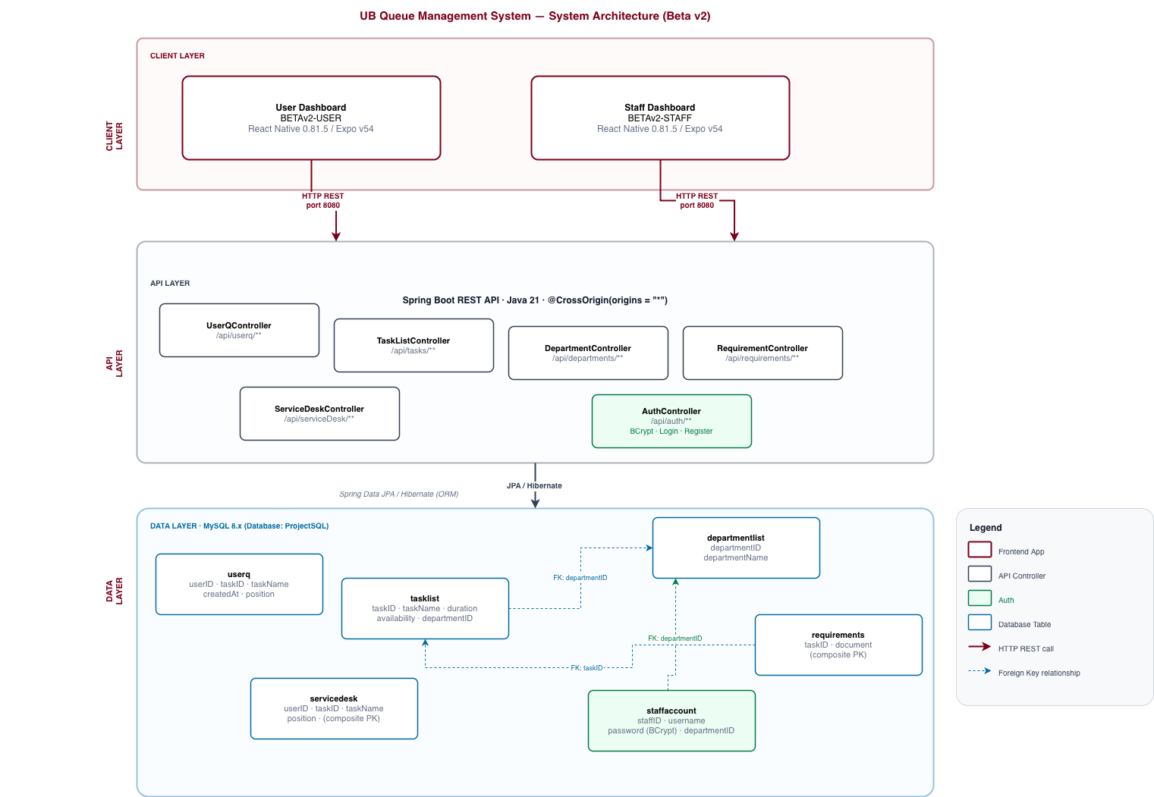

3. Technology Stack

Backend
Technology | Version | Purpose
Java | 21 | Runtime
Spring Boot | 4.0.3 | Web framework
Spring Data JPA | (via Boot) | ORM layer
Hibernate | (via JPA) | SQL generation
MySQL Connector/J | (latest) | Database driver
Lombok | (latest) | Boilerplate reduction
H2 Database | (runtime) | In-memory test DB
Spring Security Crypto | (via Boot) | BCrypt password hashing
Maven | (wrapper) | Build & dependency management

Frontend
Technology | Version | Purpose
React Native | 0.81.5 | Cross-platform mobile/web UI
Expo | v54 | Build toolchain & native APIs
React Navigation | (native-stack) | Screen navigation
React Native Picker | (community) | Dropdown selectors
Fetch API | (built-in) | HTTP requests

4. System Requirements

Development Machine
- OS: macOS, Windows, or Linux
- Java: JDK 21+
- Maven: 3.8+ (or use included ./mvnw)
- Node.js: 18+
- npm: 9+
- MySQL: 8.0+
- Expo CLI: npm install -g expo-cli (optional, npx expo works)

Runtime
- Backend: Any machine with Java 21+ and MySQL access
- Frontends: Any device with a modern browser or Android/iOS (via Expo Go)

5. Backend - Spring Boot API

Data Models

‘UserQ’ - Queue Entry
Represents a user's current position in the queue.
Field | Type | Constraints | Description
userID | Integer | Primary Key | Auto-generated 5-digit ID (10000–99999)
taskID | Integer | - | Foreign reference to TaskList.taskID
taskName | String | - | Denormalized task name for display
createdAt | LocalTime | - | Time the user joined the queue
position | Integer | - | Stored position value

ID Generation Logic (UserQController): A random integer between 10000 and 99999 is generated and checked for uniqueness before insertion.

‘TaskList’ - Service / Task
Represents a service offered by a department.
Field | Type | Constraints | Description
taskID | Integer | Primary Key | Unique service identifier
taskName | String | - | Human-readable service name
duration | LocalTime | - | Estimated service duration (HH:MM:SS)
availability | String | "Available" / "Unavailable" | Whether users can join this queue
department | DepartmentList | @ManyToOne | Owning department

‘DepartmentList’ - Department
Field | Type | Constraints | Description
departmentID | Integer | Primary Key | Unique department identifier
departmentName | String | - | Display name

‘Requirements’ - Task Documents
Composite-key entity listing required documents per task.
Field | Type | Constraints | Description
taskID | Integer | Composite PK (part 1) | Links to TaskList
document | String | Composite PK (part 2) | Document name (e.g., "Passport")
Composite Key class: RequirementsKey

‘ServiceDesk’ - Service Desk Queue
Composite-key entity tracking user-task assignments at the desk.
Field | Type | Constraints | Description
userID | Integer | Composite PK (part 1) | Linked queue user
taskID | Integer | Composite PK (part 2) | Linked task
taskName | String | - | Denormalized display
position | Integer | - | Position at desk
Composite Key class: ServiceDeskKey

‘StaffAccount’ - Staff Credentials
Stores staff login credentials linked to a department.
Field | Type | Constraints | Description
staffID | Integer | Primary Key, auto-increment | Unique staff identifier
username | String | UNIQUE, NOT NULL | Login username
password | String | NOT NULL | BCrypt-hashed password
department | DepartmentList | @ManyToOne, NOT NULL | Associated department
Password Storage: Passwords are hashed with BCryptPasswordEncoder (Spring Security Crypto). Plain-text passwords are never persisted.

REST API Reference
All endpoints are prefixed with /api. CORS is globally open (origins = "").

Users / Queue - ‘/api/userq’
Method | Endpoint | Description | Request Body / Params | Response
GET | /api/userq/all | Retrieve all queue entries | - | List<UserQ>
GET | /api/userq/{userID} | Get a specific user entry | Path: userID | UserQ or 404
GET | /api/userq/count | Total number of users in queue | - | Integer
GET | /api/userq/position/{userID} | Get user's position in their department queue | Path: userID | Integer
GET | /api/userq/department/{departmentID} | All users in a department's queue | Path: departmentID | List<UserQ>
POST | /api/userq/queue?taskID={id} | Add user to queue | Query: taskID | UserQ (with assigned userID)
DELETE | /api/userq/remove/{userID} | Remove user from queue | Path: userID | 200 OK

Tasks - ‘/api/tasks’
Method | Endpoint | Description | Request Body | Response
GET | /api/tasks/all | All tasks | - | List<TaskList>
GET | /api/tasks/department/{departmentID} | Tasks for a department | - | List<TaskList>
POST | /api/tasks/add | Create a new task | TaskList JSON | TaskList
PUT | /api/tasks/update/{id} | Update task fields | TaskList JSON | TaskList
DELETE | /api/tasks/delete/{id} | Delete task (cascades) | - | 200 OK
Cascade on delete: Removes associated Requirements, UserQ entries, and ServiceDesk entries.

Departments - ‘/api/departments’
Method | Endpoint | Description | Response
GET | /api/departments/all | All departments | List<DepartmentList>

Requirements - ‘/api/requirements’
Method | Endpoint | Description | Request Body | Response
GET | /api/requirements/task/{taskID} | Requirements for a task | - | List<Requirements>
POST | /api/requirements/add | Add a requirement | Requirements JSON | Requirements
DELETE | /api/requirements/delete/{taskID}/{document} | Remove a requirement | - | 200 OK

Service Desk - ‘/api/serviceDesk’
Method | Endpoint | Description | Response
GET | /api/serviceDesk/all | All service desk entries | List<ServiceDesk>
GET | /api/serviceDesk/position/{userID} | User's desk position + required docs | Object
DELETE | /api/serviceDesk/delete/{userID}/{taskID} | Remove desk entry | 200 OK

Authentication - ‘/api/auth’
Method | Endpoint | Description | Request Body | Response
POST | /api/auth/login | Authenticate a staff member | { "username": "...", "password": "..." } | { staffID, username, departmentID, departmentName } or 401
POST | /api/auth/register | Create a new staff account | { "username": "...", "password": "...", "departmentID": 1 } | { message, username } or 400/409

Login response (200 OK):
{
“staffID”:1,
“username”: “finance_staff”,
“departmentID”:1,
“departmentName”: “Finance Office”
}
Note: The ‘/register’ endpoint should be restricted or removed after initial staff account setup in production.

Database Schema

Database name: ProjectSQL
-- Departments
CREATE TABLE departmentlist (
departmentID INT PRIMARY KEY,
departmentName VARCHAR(255)
);

-- Tasks / Services
CREATE TABLE tasklist (
taskID INT PRIMARY KEY,
taskName VARCHAR(255),
duration TIME,
availability VARCHAR(50), -- 'Available' or 'Unavailable'
department_departmentID INT,
FOREIGN KEY (department_departmentID) REFERENCES departmentlist(departmentID)
);

-- User Queue Entries
CREATE TABLE userq (
userID INT PRIMARY KEY, -- Random 5-digit, 10000-99999
taskID INT,
taskName VARCHAR(255),
createdAt TIME,
position INT
);

-- Task Requirements (documents)
CREATE TABLE requirements (
taskID INT,
document VARCHAR(255),
PRIMARY KEY (taskID, document),
FOREIGN KEY (taskID) REFERENCES tasklist(taskID)
);

-- Service Desk Queue
CREATE TABLE servicedesk (
userID INT,
taskID INT,
taskName VARCHAR(255),
position INT,
PRIMARY KEY (userID, taskID)
);

-- Staff Accounts
CREATE TABLE staffaccount (
staffID INT PRIMARY KEY AUTO_INCREMENT,
username VARCHAR(255) NOT NULL UNIQUE,
password VARCHAR(255) NOT NULL, -- BCrypt hash
departmentID INT NOT NULL,
FOREIGN KEY (departmentID) REFERENCES departmentlist(departmentID)
);
Note: JPA ‘ddl-auto=update’ manages schema creation automatically. The SQL above is for reference.

Sample Data
A sample_data.sql script is included in the project root. Run it after the backend has started at least once (so JPA can create the tables). It seeds all five departments, tasks, requirements, queue entries, service desk entries, and staff accounts.

Staff accounts included in the seed data:
Username | Password | Department
finance_staff | Finance@2026 | Finance Office
registrar_staff | Registrar@2026 | Registrar's Office
student_affairs | StudentAffairs@2026 | Student Affairs
it_staff | ITServices@2026 | IT Services
library_staff | Library@2026 | Library Services

Configuration

File: backend/src/main/resources/application.properties
spring.application.name=backend

# MySQL DataSource
spring.datasource.url=jdbc:mysql://localhost:3306/ProjectSQL
spring.datasource.username=root
spring.datasource.password=12345678
spring.datasource.driver-class-name=com.mysql.cj.jdbc.Driver

# JPA / Hibernate
spring.jpa.database-platform=org.hibernate.dialect.MySQLDialect
spring.jpa.hibernate.ddl-auto=update
spring.jpa.hibernate.naming.physical-strategy=org.hibernate.boot.model.naming.PhysicalNamingStrategyStandardImpl
spring.jpa.show-sql=true

Security Note: Change ‘spring.datasource.password’ before any non-local deployment and never commit credentials to version control.

6. User Dashboard - BETAv2-USER

Entry Point
BETAv2-USER/UserDashboard/App.js - sets up React Navigation with a NativeStack navigator. Initial screen: UserWelcomeScreen.

Screen Reference
Screen | File | Route Name | Purpose
Welcome | UserWelcomeScreen.js | "Home" | Landing page with "Join the Queue" and "Check Queue Status" navigation
Join Queue | JoinScreen.js | "Join" | Select department/task, join queue
Queue Status | StatusScreen.js | "Status" | Look up queue ID, view live position, cancel

Key Logic – UserWelcomeScreen
- Desktop/tablet layout: split-panel - left maroon branding panel (logo, title, feature list) + right action panel with two large buttons.
- Mobile layout: full-screen maroon background with a centered white card containing the logo, title, and two action buttons.
- Uses useResponsive() to switch between layouts at the md (768px) breakpoint.

Key Logic - JoinScreen
- On mount: fetches /api/departments/all to populate department dropdown.
- On department select: fetches /api/tasks/department/{id}. All tasks are shown in the picker; unavailable tasks display a warning banner.
- On submit: POST /api/userq/queue?taskID={id} - on success, navigates directly to StatusScreen with the returned userID pre-loaded (initialUserID route param).
- Responsive layout: two-column (form + info panel) on tablet/desktop; single-column card stack on mobile.

Key Logic - StatusScreen
- Accepts initialUserID route param - if present, auto-fetches status on mount.
- On lookup: parallel Promise.all calls to /api/userq/{userID} and /api/userq/position/{userID}.
- Fetches /api/requirements/task/{taskID} to list required documents.
- Auto-polling: starts a 30-second interval (POLL_INTERVAL_MS = 30000) after a successful lookup; silently updates the displayed position.
- Position alerts: when position drops to ≤ 3 (ALERT_THRESHOLD), an alert prompts the user to stay nearby. When position reaches 1, a "You're Next!" alert fires once per lookup session.
- On cancel ("Leave Queue"): DELETE /api/userq/remove/{userID} with confirmation dialog; polling stops on cancel.
- Responsive layout: two-column (lookup panel + status display) on tablet/desktop; single-column on mobile.

API Configuration
BETAv2-USER/UserDashboard/constants/Api.js
export const IP_ADDRESS = 'localhost';
export const PORT = '8080';
export const API_BASE_URL = ‘http://${IP_ADDRESS}:${PORT}/api’;

7. Staff Dashboard

Entry Point
BETAv2-STAFF/StaffDashboard/App.js - same stack navigation pattern. Initial screen: WelcomeScreen.

Screen Reference
Screen | File | Route Name | Purpose
Staff Welcome | WelcomeScreen.js | "Welcome" | Username/password login
Queue View | StaffDashboard.js | "Staff" | Live queue for department, serve users
Task Manager | ManageTasks.js | "ManageTasks" | CRUD for tasks and requirements

Key Logic - WelcomeScreen (Login)
- Displays a username and password form.
- On submit: POST /api/auth/login with { username, password }.
- On success: navigates to StaffDashboard passing departmentID, departmentName, staffID, and username from the response.
- On failure: displays the error message returned by the API (e.g. "Invalid username or password.").

Key Logic - StaffDashboard
- Receives departmentID and departmentName via route params.
- Fetches /api/userq/department/{departmentID} on mount and every 10 seconds (auto-refresh via setInterval).
- Sorts queue by createdAt (ascending - first in, first served).
- Removal: DELETE /api/userq/remove/{userID} with Alert.alert confirmation.

Key Logic - ManageTasks

Existing Tasks:
- Loads all tasks (/api/task/all) and requirement per task on mount (/api/requirements/task/{taskID})
- Task cards are collapsible; only one expands at a time.
- Updates via PUT /api/tasks/update/{taskID} with the full updated task object.
- Cascading delete via DELETE /api/tasks/delete/{taskID}.

New Task Form:
- Fields: Task ID (manual), Task Name, Duration (HH:MM:SS), Availability (toggle), Department (picker).
- Submits via POST /api/tasks/add.

Requirements Management:
- Per-task text input adds new document: POST /api/requirements/add.
- Inline delete button: DELETE /api/requirements/delete/{taskID}/{document}.

8. Installation & Setup

Database Setup

-- In MySQL shell or workbench
CREATE DATABASE ProjectSQL;
USE ProjectSQL;
-- Tables are created automatically by JPA on first run
After the backend has started once and JPA has created all tables, load the sample data:

mysql -u root -p ProjectSQL < sample_data.sql
This seeds departments, tasks, requirements, queue entries, service desk entries, and staff accounts.

Backend Setup
cd "{src directory}"

# Build
./mvnw clean install

# Run
./mvnw spring-boot:run
The API will start at http://localhost:8080.

User Dashboard/ Staff Dashboard Setup
cd "{src directory}"
npm install
npx expo start

9. Running the System

Start components in this order:

- MySQL - ensure the service is running and ProjectSQL database exists.
- Backend - ./mvnw spring-boot:run inside backend/.
- User Dashboard - npx expo start inside BETAv2-USER/UserDashboard/.
- Staff Dashboard - npx expo start inside BETAv2-STAFF/StaffDashboard/.

10. API Configuration (Frontend)

Both dashboards share the same pattern. To point the frontends at a different backend host:

User Dashboard: BETAv2-USER/UserDashboard/constants/Api.js
Staff Dashboard: BETAv2-STAFF/StaffDashboard/constants/Api.js

// Change IP_ADDRESS to the backend machine's IP on your network
export const IP_ADDRESS = '192.168.1.100'; // example
export const PORT = '8080';
export const API_BASE_URL = ‘http://${IP_ADDRESS}:${PORT}/api’;
On physical devices, ‘localhost’ refers to the device itself. You must use the backend machine's LAN IP (e.g., ‘192.168.x.x’).

11. Known Limitations & Security Notes

Area | Issue | Recommendation
Authentication | Staff login uses BCrypt password verification, but there is no session/token management - the frontend receives no JWT/session; any client can still call staff-only endpoints directly | Add JWT or session tokens; add Spring Security filter to protect staff endpoints
Staff Registration | POST /api/auth/register is open with no admin guard | Remove or restrict after initial account setup
CORS | @CrossOrigin(origins = "") allows all origins | Restrict to known frontend origins in production
Database credentials | Hardcoded in application.properties | Use environment variables or a secrets manager
API URL | Hardcoded localhost:8080 in frontend constants | Use a config file or environment variable per build target
User ID generation | Random 5-digit int - collisions possible under high concurrency | Use a database sequence or UUID
No HTTPS | All communication is plain HTTP | Add TLS/SSL for any network beyond localhost
ddl-auto=update | Can alter schema unexpectedly in production | Switch to validate or use Flyway/Liquibase for migrations
No input validation on frontend | Text fields accept any value | Add length and format validation to all form fields

